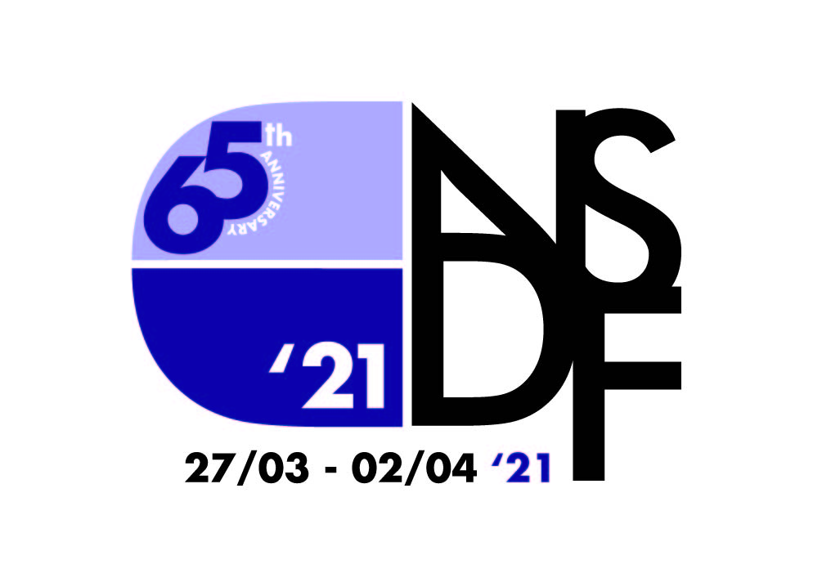

Welcome to NSDF 21

This is our 65th Annual Festival.

None has been made in stranger circumstances.

None has shown more clearly the resilience of young people.

None has made us prouder.

We have 17 new pieces of work. New art, new artists and new communities. Companies of brilliant young people from across the country. Because of the pandemic many of them have never even met. But against the odds they have been creating work together, mentored by our Associates.

It’s been a wild, inspiring ride.

We’re presenting finished shows, readings and works in progress. We’re so excited and proud of what they’ve made. Every one of them fills us with hope.

Just that phrase- “Work in Progress”- tells us that our industry and the creativity it exists to serve will return strong after the plague. That things will begin again. And, we hope, begin again better.

I want to say thank you to every one of our amazing sponsors, partners and supporters, and of course to ACE and the Sunday Times, without which the work of NSDF would be impossible.

But I want to say a special thank you to one person.

Our Executive Director Kim Grant.

Kim is leaving that role after the Festival, although she will not be leaving our NSDF Family of which she is such an integral and vital part.

At NSDF we try to think often of how we can be useful. Kindness without competence is just gestural, competence without kindness is too often a disguised cruelty. Kim has lent this organisation her extraordinary kindness and her unmatched skills and competence for more than two years. Nothing we have achieved with our new NSDF would have been possible without her. She is mighty.

It’s been a tough year, a long winter.

We think new voices are the birdsong that will let us know spring has arrived.

So let’s begin.

Code of Practice

Online Safety Code of Practice for Participants

This code will be distributed to all Participants before any NSDF online activity begins. All Participants must confirm that they have read and understood this code before taking part in the activity. If the Participant is Under 18, they must also provide the signature of their parent or legal guardian.

Participants of all ages should:

- treat all Participants equally, with respect and dignity.

- be aware that Participants include both adults and under 18’s.

- never send anyone material that could be considered threatening, bullying, offensive or illegal.

- never arrange a face-to-face meeting with someone you meet online unless you have discussed with your parents/legal guardian if Under 18 and/or NSDF Staff.

- be aware that you can contact NSDF’s Young Person Protection Officer (YPPO) with any concerns or incidents on 07539768087 or lizzie@nsdf.org.uk and if you cannot get through to Lizzie, please email James Phillips james@nsdf.org.uk or call 07798608847.

- be aware that NSDF Staff and Festival Team is required to adhere to this policy which is in place to protect Participants against potential harm and should feel confident in reporting any concerns or incidents.

  - If possible seek out NSDF’s YPPO to pass on the information confidentially. This is for the protection of any potentially vulnerable individual(s). Any NSDF member of Staff or Festival Team should be able to direct you appropriately.

  - If this is not possible pass the information to any NSDF member of Staff or Festival Team or call 999 in the case of genuine emergency.

- Please respect the fact that everyone has their own access requirements.

Please contact our Young Person Protection Officer (YPPO), Lizzie Melbourne by email lizzie@nsdf.org.uk or phone 07539768087 if you would like to chat further.

Supporters

Arts Council England
Here For Culture
The Sunday Times
Society of London Theatre through the Theatre Development Trust
SLX
Blackout
Spotlight
Paines Plough
Slung Low
Curve
Leicester City Council
Andrew Lloyd Webber Foundation
The Mackintosh Foundation
The Martin Bowley Charitable Trust
The Ashley Family Foundation
Noel Coward Foundation
The Garrick Charitable Trust
The D’Oyly Carte Charitable Trust
Good CRM
New Adventures
Barrel Organ
Shedinburgh
Zero 88
ETC

Full details of participation, attendance
and access can be found on our website.

www.nsdf.org.uk

More Technical Theatre workshops
will be added to our website over the week.

Saturday 27 March 2021

All events feature automated closed captioning unless specified that captioning is live.

10:00-10:45 NSDF Morning Adventures with New Adventures with Gavin Eden
10:00-10:30 Introduction to the Technical Team
10:30-11:00 Stage Management 101
11:00-12:00 Noises Off: Introduction to reviewing with Florence Bell and Naomi Obeng
11:00-13:00 Combining film & theatre: The making of The Good Book with Brett Chapman
11:00-13:00 Creative Access with Nickie Miles-Wildin and Chloë Clarke (Live captions)
11:00-11:30 Lighting 101
11:30-12:00 Sound 101
12:00-12:30 Video 101
12:00-13:00 The power of DYSLEXIA+ in a wordy industry (Part 1)
12:30-13:00 Rigging 101
13:00-14:00 Meeting space for Ethnically Diverse participants at NSDF 21 (Live captions)
14:00-16:00 to hunt violets | juniper theatre (Live captions)
16:00-17:00 Alexander Zeldin in conversation with Elin Schofield (Live captions)
17:10-18:10 Nikolai Foster in conversation with Grace Smart (Live captions)
17:00-18:00 Lucy Hind in conversation with James Phillips (Live captions)
18:00-19:00 Meeting space for LGBTQIA+ participants at NSDF 21 (Live captions)
19:30-20:45 Seen | Take a Breath
(Captioned pre-record followed by a Q&A with automated captions)
21:00-21:30 NSDF Presents: Lockdown Stories (Captioned pre-record)
Sunday 28 March 2021

All events feature automated closed captioning unless specified that captioning is live.

10:00-10:45 NSDF Morning Adventures with New Adventures with Nicole Kabera
10:00-12:30 Flying Solo - Production by the seat of your pants!
10:00-11:00 Level-Up Your Zoom Game
10:30-11:30 Deaf, Disabled and Neuro-Diverse Participant Meetup (Live captions and BSL Interpreted)
11:00-12:00 Writing and performing your own work with Yolanda Mercy
11:00-12:00 Site-Specific and Outdoor producing with Charlie Bunker
11:00-13:00 Set Electrics
12:00-13:00 Story Structure with Sam Steiner
12:30-13:30 Risk Assessments?
13:00-14:00 Money, Money, Money – Funding Your Show
14:00-15:50 This is a Love Song | Tiny Change Theatre
(Captioned pre-record followed by a Q&A with automated captions)
14:00-15:00 The Light Catcher | Theatron Entertainment, Pune and Thespo (Captioned pre-record)
16:00-17:00 Rory Kinnear in conversation with James Phillips (Captioned pre-record)
16:00-18:00 Edinburgh Calling - Working the Fringe (Live captions)
18:00-19:00 WOW Festival Meetup (Live captions)
17:00-18:00 Eleanor Lloyd in conversation with Donna Munday (Live captions)
19:30-20:40 Beneath the Surface | Big Creative Academy
(Captioned pre-record followed by live Q&A with automated captions)
21:00-22:30 The NSDF Quiz (Live captions)
Monday 29 March 2021

All events feature automated closed captioning unless specified that captioning is live.

09:30-11:30 Getting to Grips with QLab
09:30-11:00 We Need To Talk – People are Scary
10:00-10:45 NSDF Morning Adventures with New Adventures with Bryony Harrison
10:45-11:45 Status, Value and Confidence with Lucy Hind
11:00-12:00 Meet the New Myths – Same as the Old Myths with the School of Night
11:00-13:00 Demystifying Video with Will Duke
11:30-13:00 On Book: Getting Started as a Deputy Stage Manager
12:00-13:00 Inspiring Creativity with Katie Posner
12:00-13:00 Creative Criticism with Maddy Costa
12:10-13:10 Audition Secrets with Hannah Miller, Casting Director at the RSC (Live captions)
13:00-14:00 Chai @ Tapri with Thespo
14:00-14:40 The SCRUBBERS Guide to Drama School | SCRUBBERS
15:00-15:40 The SCRUBBERS Guide to Drama School | SCRUBBERS
16:00-17:00 Clint Dyer in conversation with Mark Shenton (Live captions)
16:00-18:00 Neil Austin and Frankie Bradshaw in Conversation (Live captions)
17:10-18:10 Polly Findlay in conversation with Peter Bradley (Live captions)
19:30-20:45 Not Near Enough | Gwirvos Theatre
(Captioned pre-record followed by live Q&A with automated captions)
21:00-22:15 HOME | Undereaves Theatre
(Captioned pre-record followed by live Q&A with automated captions)

Tuesday 30 March 2021

All events feature automated closed captioning unless specified that captioning is live.

10:00-10:45 NSDF Morning Adventures with New Adventures with Dominic North
10:00-11:30 How the Hell Did I End up Here?
10:00-11:30 Get Lit: A Beginners Guide to Lighting
11:00-12:00 Katy Brand in conversation with James Phillips (Live captions)
11:00-12:00 Self-penned performance with Charlie Josephine
11:00-13:00 Devising with The Paper Birds
11:30-13:00 Lighting Control with Zero 88
11:30-13:00 Dave’s Acoustic Workshop
12:10-13:10 Help, I’m Writing Something! with Chris Thorpe
11:30-13:00 Movement on Zoom: limiting or limitless? with Elin Schofield
13:00-14:00 Making Theatre for a Digital Audience: Where do I Start?
14:00-14:40 The SCRUBBERS Guide to Drama School | SCRUBBERS
15:00-16:00 The SCRUBBERS Guide to Drama School | SCRUBBERS
(Live captioned performance followed by a live captioned Q&A)
16:00-17:00 Bunny Christie in conversation with Grace Smart (Live captions)
17:10-18:10 Panel Discussion: Is Theatre Shit? And How do we make it better?
(Live captions and BSL Interpreted)
19:30-21:15 Jigsaw | Pound of Flesh
(Captioned pre-record with audio description version available, followed by live Q&A with automated captions)
21:30-22:30 Rum & Coke | Mistaken Identity Theatre Company
(Captioned pre-record followed by live Q&A with automated captions)
Wednesday 31 March 2021

All events feature automated closed captioning unless specified that captioning is live.

10:00-10:45 NSDF Morning Adventures with New Adventures with Ross Carpenter
10:00-12:00 Theatre: Tradition and Revolt! With Filter Theatre
10:00-11:45 Audition Hints and Tips with Debbie Korley
10:00-11:30 Working with Hire Companies with SLX
10:00-11:15 Virtual Reality
11:00-12:00 Are people laughing…or are they all on mute? (Clowning Online) with Grace Gallagher
11:00-13:00 Introduction to Gig Theatre with Marc Graham, Middle Child
11:15-12:30 Streamed Productions: Not Just For Lockdown
11:30-13:00 Mixing Colour with LED with ETC
13:00 Backstage at The…Royal Albert Hall (Captioned pre-record)
12:00-13:00 Importance of Design with Grace Smart
13:00-14:00 Chai @ Tapri with Thespo
14:30-15:50 Common Ground | Thunk-It Theatre and Barrel Organ (Live captions)
16:00-18:00 An Introduction to Rigging for the Entertainment Industry (Live captions)
16:00-17:00 Tamsin Greig in conversation with Simon Godwin (Live captions)
17:10-18:10 Phyllida Llloyd in conversation with Elin Schofield (Live captions)
19:30-20:45 In A Cave, a Voice | The Pembroke Players, Cambridge University
(Captioned audio-play with atmospheric visuals)
21:30-22:30 Open Mic Night (Live captions and BSL Interpreted)

Thursday 1 April 2021

All events feature automated closed captioning unless specified that captioning is live.

10:00-10:45 NSDF Morning Adventures with New Adventures with Sophia Hurdley
10:00-11:30 Directing vs Assistant Directing with Elin Schofield
10:00-11:30 3D Printing for Theatre with David Farley
10:00-11:30 Managing the Juice: Production Electrics
11:30-13:00 Producing: Proper Job – Honest! with Chris Grady
11:30-13:00 Which Light is Right? with ETC
11:30-13:00 The Immersive Audio Revolution
12:00-13:00 Make new work from nothing! with Lucy McCormick
12:00-13:00 The power of DYSLEXIA+ in a wordy industry: Part 2
13:00-14:00 To Train or not to Train: Should I go to Drama School?
14:30-16:00 Genius | Fishbowl Theatre
16:00-17:00 Josh O’Connor in conversation with Andy Apollo (Captioned pre-record)
16:00-18:00 In Conversation with Dick Straker (Live captions)
17:00-18:00 Panel Discussion: Leadership in the Arts - are we well led, and how can we do better? (Live captions and BSL Interpreted)
19:30-21:00 Vibrations | GABII
(Captioned pre-record followed by a Q&A with automated captions)
21:00-22:30 NOFF, Paper, Scissors - making our festival zine

Friday 2 April 2021

All events feature automated closed captioning unless specified that captioning is live.

10:00-10:45 NSDF Morning Adventures with New Adventures with Jamie McDonald
10:00-10:45 Self-Employment: A Beginner’s Guide (Session 1)
10:00-10.45 Follow-me (remote follow spot control, it’s the future!) with Ben Linwood
11:00-12:00 Creating Immediate response political theatre with Nadia Emam
11:00-12:30 Site Visits for Touring Theatre with Curve Theatre
11:00-13:00 How to get your first job in theatre producing with Donna Munday
12:00-13:00 Playing The Game With Your Own Rules: Staying true to yourself in the industry with Nima Taleghani and Angus Imrie
12:00-13:00 Verbatim Bootcamp with LUNG
12:30-13:15 Self-Employment: A Beginner’s Guide (Session 2)
13:00-14:00 Chai @ Tapri with Thespo
14:30-15:45 The Choir (Live captions followed by a Q&A with automated captions)
16:00-17:00 Daniel Bailey in conversation with Ray Sesay (Captioned pre-record)
17:00-18:00 Lucy Briers in conversation with Giles Terera (Live captions)
19:30-20:20 You Will See Everything | Definitely Fine
(Captioned pre-record, including audio described introduction, followed by Q&A with automated captions)
20:30-21:00 NSDF Presents: Where We’re Going
(Captioned pre-record)
21:00-22:00 DJ Afterparty with Will Jackson (Live captions and BSL Interpreted)

Credits

NSDF 65th
Anniversary Festival Patron
Stephen Fry

Patrons
Sir Alan Ayckbourn
Meera Syal CBE

President
Pat Wolfe

Trustees
Anthony Alderson
Daniel Brodie
Emma Kendall
Donna Munday
Sarah Nicholson (Chair)
Mark Shenton
Yasmin Hafesji

Staff
James Phillips - Director
Kim Grant - Executive Director
Lizzie Melbourne - General Manager
Graeme Nixon - Technical Director
Ellie Fitz-Gerald - Coordinator
Brett Chapman - Digital Producer

Technical Workshop
Coordinators
Lucy Jenkins
Jasmin Davies

Creative Access Consultants
Nickie Miles-Wildin
Chloë Clarke

NSDF CREATES
Ali Pidsley
Anna Himali Howard
Debbie Korley
Elin Schofield
Gabby Vautier
Helen Goalen
Nima Taleghani
Ray Sesay
Sam Steiner

Barrel Organ
Ali Pidlsey
Ellie Claughton
Rosie Gray

Associates
Abbi Greenland
Ali Pidsley
Anna Himali Howard
Brett Chapman
Chris Thorpe
Debbie Korley
Elin Schofield
Gabby Vautier
Grace Smart
Helen Goalen
Jennifer Tang
Joanna Resnick
Lucy Ellinson
Marc Graham
Nadia Emam
Nickie Miles-Wildin
Nima Taleghani
Olivia Vinall
Peter Bradley
Psyche Stott
Ray Sesay
Roy Alexander-Weise
Sam Steiner
Sean Linnen
Tinuke Craig

Technical Team
Adam Wileman
Ali Stringer
David Butler
David Kett
Iain Orr
Jasmin Davies
Jake Rowe
Jack Simpson
Lucy Jenkins
Rowan Read
Sam House

Management Team
Alexander Cohen
Brad Mell
Danni Watmore
Emily Hamilton
Emily Prior
Emily Wilkinson
Erin Waks
Gabbie Sills
Hana Kohout
Jade Parkin
Katie Blackwell
Lilian Race
Lucy Donald
Malwina Rog
Megan Stephens
Misha Mah
Nancy Case
Natalie Chan
Nicole Henson
Olivia Swain
Pippa Le Grand
Saxon Mudge

Noises Off Editors
Naomi Obeng
Florence Bell

Noises Off Journalists
Anna Mahtani
Beth Edwards
Elisha Pearce
Emma Robinson
Estibaliz Bragado
Issy Flower
Katie Kirkpatrick
Lydia Kendall-McDougall
Mark Smith
Rosie Thackery
Sam Ross
Shamsa Kiwanuka

Noises Off
Photographer
Beatrice Debney

Noises Off Designer
Robin Wilde

Programme Design
Laura Brannagan
laurabdesign.co.uk
NSDF would like to offer immense thanks to:
Anushka Ghose
Barrel Organ
Big Creative Academy
Everyone at Curve
Falmouth University
Kate Morley
New Adventures
New VIc Sixth Form College
Everyone at Paines Plough
Srishti Ray
Everyone at Slung Low
Spotlight
Tamara Harvey
Thespo
Zosh Skowronska

